Form-C (EPI)

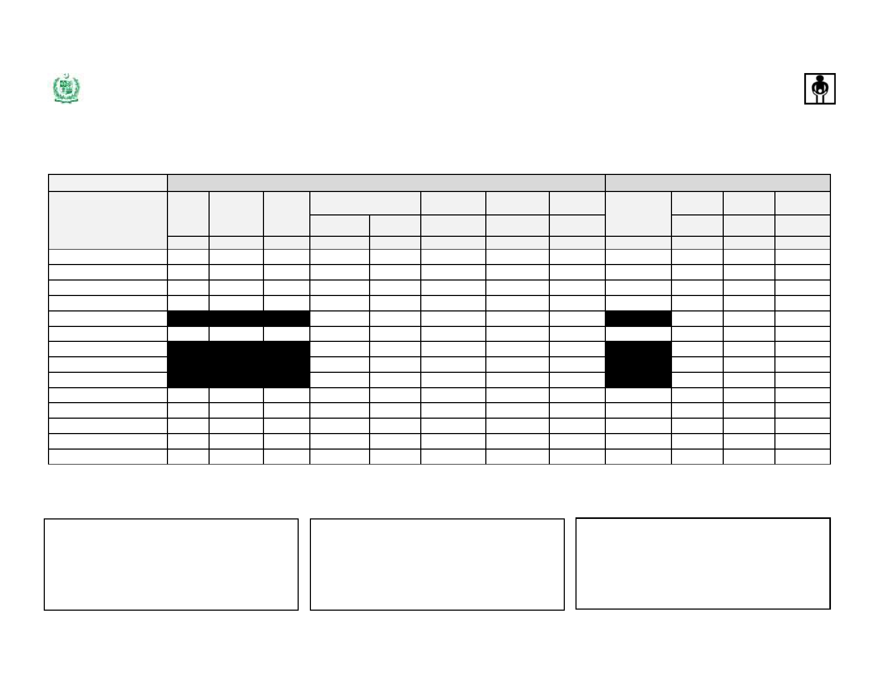

***Expanded Program on Immunization, Government of Pakistan***

**Demand, Consumption & Receipt Form**

**Campaigns Type (**  **)**

**UC _______________ Tehsil: __________________ District: _________________ Province:_________________ Campaign Date: from ______________**  **to _______________(MM/YY)**

**DEMAND**  **CONSUMPTION**

**Doses**

**per Vial**

**Target #**

**Wastage**

**factor**

**Required**

**Opening**

**Balance**

**Requested**

**G=E-F**

**Received**

**Children**

**Vaccinated/**

**Vials Used**

**Unusable**

**Vials**

**Closing**

**Balance**

**Product**

**A**

**B**

**C**

**Doses**

**D= B x C**

**D**

**Vials/Nos.**

**E=D/A**

**E**

**Vials/Nos.**

**F**

**Vials/Nos.**

**G**

**Vials/Nos.**

**H**

**Doses**

**Administered**

**I**

**Vials/Nos.**

**J**

**Vials/Nos.**

**K**

**Vials/Nos.**

**L**

**mOPV1**

**bOPV tOPV**

**Measles**

**DIL Measles**

**TT**

**AD Syringes 0.5 ml**

**Recon. Syringes (5 ml)**

**Safety Boxes**

20

20 20 10

20

1.12

1.12 1.12 1.11

1.11

Note:

i. Use blank rows, if needed to add more than one batch received for one product/new products

ii. Columns B to G to be filled and sent to the issuing authority at least 2 weeks before the SIA. Column H to K to be filled and sent within 1 week after completion of the SIA

**Requested by** - **Received by** - **Reported by** -

Name & Designation:_________________________________ Name & Designation:_________________________________ Name & Designation:_________________________________

Store Name: ________________________________________ Store Name: ________________________________________ Store Name: ________________________________________

Signature & Date:____________________________________ Signature & Date:____________________________________ Signature & Date:____________________________________